Laboratory work #3

Lamport’s logical clocks

Student: CAO Xinyang  
Student HDU ID: 20321308

Mail:

[c.x_yang@foxmail.com](mailto:c.x_yang@foxmail.com)

Screenshot or copy with mail with “Passed”:

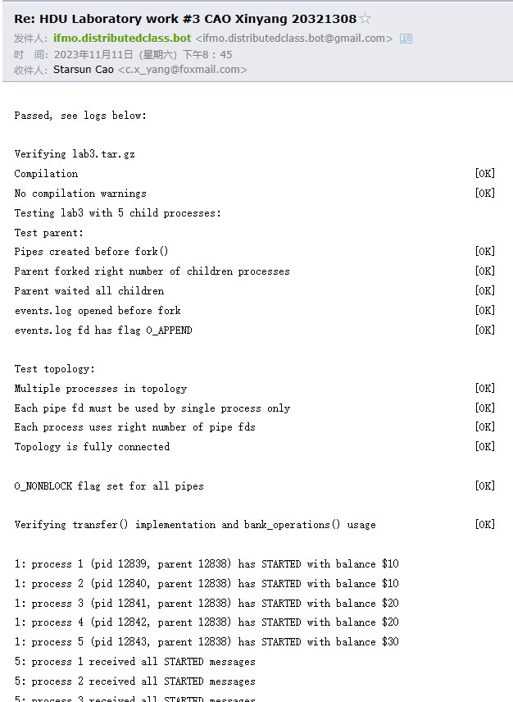

Control questions:

1. Lamport’s clocks. What does it mean, that these clocks aren’t strongly consistent?

Answer:

Lamport’s clocks, also known as logical clocks, are a mechanism used in distributed systems to order events. They provide a way to generate timestamps for events that reflect their causal ordering, which is a crucial aspect in understanding the behavior of distributed systems.

However, Lamport’s clocks are not strongly consistent. This means that while they can guarantee that if an event a causally precedes an event b, then the timestamp of a will be less than the timestamp of b, the converse is not necessarily true. In other words, if the timestamp of an event a is less than the timestamp of an event b, it does not guarantee that a causally precedes b.

2. What will happened, if parent process’s messages (e.g., TRANSFERs from parent) aren’t marked with Lamport’s clock timestamp?   
Modify your model and explain results. Attach resulted table to the report.

Answer:

The termination of the child process is governed by its own timeline, unaffected by the parent’s schedule.

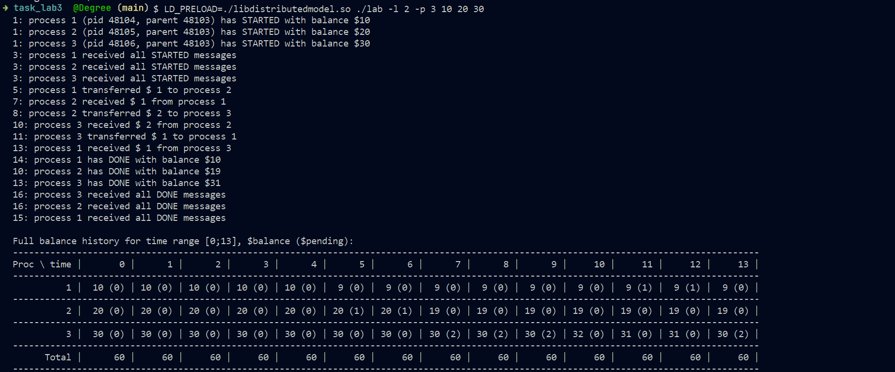

3. Make an experiment. What will happened if we will not use s_balance_pending_field?  
Modify your model and explain results. Attach resulted table to the report.

Answer:

If the “s_balance_pending_field” is not included in a specific model or system, it may lead to an unreported amount during the communication within a channel, likely due to delays.

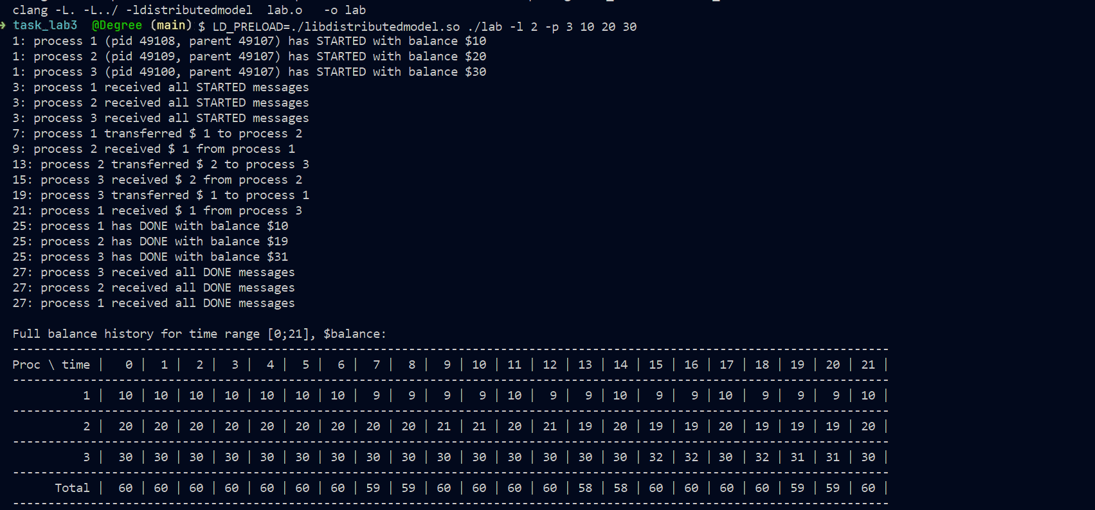

Source code:

#include <stdio.h>

#include <unistd.h>

#include <string.h>

#include <sys/types.h>

#include "labs_headers/message.h"

#include "labs_headers/log.h"

#include "labs_headers/process.h"

#include "labs_headers/banking.h"

timestamp_t Lamport_time = 0;

int max(int a, int b) {

return (a > b) ? a : b;

}

void update_history(BalanceHistory *history, timestamp_t pending_start_time, timestamp_t pending_end_time, balance_t amount, balance_t pending_money)

{

int last_time = history->s_history[history->s_history_len - 1].s_time;

int last_balance = history->s_history[history->s_history_len - 1].s_balance;

int i = last_time + 1;

while (i < pending_start_time) {

history->s_history[history->s_history_len].s_time = i;

history->s_history[history->s_history_len].s_balance = last_balance;

history->s_history[history->s_history_len].s_balance_pending_in = 0;

history->s_history_len++;

i++;

}

i = pending_start_time;

while (i < pending_end_time) {

history->s_history[history->s_history_len].s_time = i;

history->s_history[history->s_history_len].s_balance = last_balance;

history->s_history[history->s_history_len].s_balance_pending_in = pending_money;

history->s_history_len++;

i++;

}

history->s_history[history->s_history_len].s_balance = amount;

history->s_history[history->s_history_len].s_time = pending_end_time;

history->s_history[history->s_history_len].s_balance_pending_in = 0;

history->s_history_len++;

}

balance_t now_balance(BalanceHistory *history)

{

return history->s_history[history->s_history_len - 1].s_balance;

}

void parent_work(int count_nodes)

{

AllHistory all_history;

all_history.s_history_len = count_nodes - 1;

/* STUDENT IMPLEMENTATION STARTED */

/* Implement starting synchronization */

for (int i = 1; i < count_nodes; i++)

{

Message msg;

receive(i, &msg);

Lamport_time = max(Lamport_time, msg.s_header.s_local_time) + 1;

if (msg.s_header.s_magic == MESSAGE_MAGIC && msg.s_header.s_type == STARTED)

{

continue;

}

}

/* Useful work */

bank_operations(count_nodes - 1);

/* Implement finishing synchronization and collecting AllHistory */

Message msg;

fill_message(&msg, STOP, ++Lamport_time, NULL, 0);

send_multicast(&msg);

for (int i = 1; i < count_nodes; i++)

{

Message msg;

receive(i, &msg);

Lamport_time = max(Lamport_time, msg.s_header.s_local_time) + 1;

if (msg.s_header.s_magic == MESSAGE_MAGIC && msg.s_header.s_type == DONE)

{

continue;

}

}

for (int i = 1; i < count_nodes; i++)

{

Message msg;

receive(i, &msg);

Lamport_time = max(Lamport_time, msg.s_header.s_local_time) + 1;

if (msg.s_header.s_magic == MESSAGE_MAGIC && msg.s_header.s_type == BALANCE_HISTORY)

{

BalanceHistory *history = (BalanceHistory *)msg.s_payload;

memcpy(&all_history.s_history[i - 1], history,msg.s_header.s_payload_len);

}

}

print_history(&all_history);

return;

}

void child_work(struct child_arguments args)

{

/* Child arguments */

local_id self_id = args.self_id;

int count_nodes = args.count_nodes;

uint8_t balance = args.balance;

/* BalanceHistory initialization */

BalanceHistory history;

history.s_history_len = 1;

history.s_id = self_id;

memset(history.s_history, 0, sizeof(history.s_history));

history.s_history[0].s_balance = balance;

for (int i = 0; i < MAX_T; ++i) {

history.s_history[i].s_time = i;

}

/* System process identifiers used for logs */

pid_t self_pid = getpid();

pid_t parent_pid = getppid();

/* STUDENT IMPLEMENTATION STARTED */

char buf[BUF_SIZE];

Message msg;

timestamp_t current = ++Lamport_time;

snprintf(buf, BUF_SIZE, log_started_fmt, current, self_id, self_pid, parent_pid, balance);

fill_message(&msg, STARTED, current, buf, strlen(buf));

send_multicast(&msg);

shared_logger(buf);

Message recv_msg;

int cnt = 0;

for (int i = 1; i < count_nodes; i++) {

if (i == self_id)

continue;

receive(i, &recv_msg);

Lamport_time = max(Lamport_time, recv_msg.s_header.s_local_time) + 1;

if (recv_msg.s_header.s_magic == MESSAGE_MAGIC && recv_msg.s_header.s_type == STARTED) {

cnt++;

}

}

if (cnt == count_nodes - 2) {

current = Lamport_time;

snprintf(buf, BUF_SIZE, log_received_all_started_fmt, current, self_id);

shared_logger(buf);

}

cnt = 0;

while (true) {

Message req_msg;

receive_any(&req_msg);

Lamport_time = max(Lamport_time, req_msg.s_header.s_local_time) + 1;

if (req_msg.s_header.s_magic == MESSAGE_MAGIC && req_msg.s_header.s_type == TRANSFER)

{

TransferOrder *order = (TransferOrder *)req_msg.s_payload;

if (order->s_src == self_id) {

current = ++Lamport_time;

update_history(&history, current, current, now_balance(&history) - order->s_amount, 0);

snprintf(buf, BUF_SIZE, log_transfer_out_fmt, current, self_id, order->s_amount, order->s_dst);

shared_logger(buf);

Message response_msg;

fill_message(&response_msg, TRANSFER, current, order, strlen((const char*)order));

send(order->s_dst, &response_msg);

} else if (order->s_dst == self_id) {

current = max(Lamport_time, req_msg.s_header.s_local_time) + 1;

update_history(&history, req_msg.s_header.s_local_time, current, now_balance(&history) + order->s_amount, order->s_amount);

snprintf(buf, BUF_SIZE, log_transfer_in_fmt, current, self_id, order->s_amount, order->s_src);

shared_logger(buf);

Message response_msg;

fill_message(&response_msg, ACK, current, NULL, 0);

send(0, &response_msg);

}

} else if (req_msg.s_header.s_magic == MESSAGE_MAGIC && req_msg.s_header.s_type == STOP) {

current = max(Lamport_time, req_msg.s_header.s_local_time) + 1;

snprintf(buf, BUF_SIZE, log_done_fmt, current, self_id, now_balance(&history));

shared_logger(buf);

Message response_msg;

fill_message(&response_msg, DONE, current, buf, strlen(buf));

send_multicast(&response_msg);

break;

} else if (req_msg.s_header.s_magic == MESSAGE_MAGIC && req_msg.s_header.s_type == DONE) {

cnt++;

}

}

while (cnt != count_nodes - 2)

{

Message msg;

receive_any(&msg);

Lamport_time = max(Lamport_time, msg.s_header.s_local_time) + 1;

if (msg.s_header.s_magic == MESSAGE_MAGIC && msg.s_header.s_type == DONE)

{

cnt++;

}

}

if (cnt == count_nodes - 2)

{

current = Lamport_time;

snprintf(buf, BUF_SIZE, log_received_all_done_fmt, current, self_id);

shared_logger(buf);

}

Message history_msg;

current = ++Lamport_time;

fill_message(&history_msg, BALANCE_HISTORY, current, &history, sizeof(history));

send(0, &history_msg);

}

void transfer(local_id src, local_id dst,

balance_t amount)

{

TransferOrder order = {src, dst, amount};

/* STUDENT IMPLEMENTATION STARTED */

Message msg;

fill_message(&msg, TRANSFER, ++Lamport_time, &order, sizeof(order));

send(src, &msg);

receive(dst, &msg);

Lamport_time = max(Lamport_time, msg.s_header.s_local_time) + 1;

if (msg.s_header.s_magic == MESSAGE_MAGIC && msg.s_header.s_type == ACK)

{

return;

}

}

/* STUDENTS SHOULD NOT CHANGE THIS FUNCTION */

__attribute__((weak)) void bank_operations(local_id max_id)

{

int i = 1;

while (i < max_id) {

transfer(i, i + 1, i);

i++;

}

if (max_id > 1) {

transfer(max_id, 1, 1);

}

}